**Final Report**

**Nnamdi Okeke**

**009570384**

**University of San Diego**

**Date: 12/9/2023**

Table of Contents

Introduction 2

Methodology or Approach 3

Code Explanation 5

Results and Discussion 7

Challenges and Learning 11

Conclusion 11

References 13

# Introduction

In the realm of urban planning and automotive technology, the ability to analyze and understand vehicular traffic is paramount. Our project, "Intersection," is innovatively designed to address this need by leveraging advanced image processing and machine learning techniques. The primary objective of "Intersection" is to monitor, analyze, and interpret traffic flow at busy intersections, a task that holds significant implications in various sectors ranging from city planning to autonomous vehicle development. At its core, the project utilizes a sophisticated model capable of identifying and categorizing various types of vehicles. This model is not only instrumental in providing insightful data on traffic patterns, congestions, and peak hours but also plays a crucial role in facilitating smarter, data-driven decisions in urban infrastructure development and traffic regulation. Furthermore, "Intersection" extends its utility to the realms of autonomous vehicle technology, offering a tool that enhances the decision-making algorithms of self-driving cars, thereby contributing to their safety and efficiency. The project also finds applications in the advertising industry, where understanding vehicular demographics can guide targeted marketing strategies. Additionally, it serves as a valuable asset for insurance companies by aiding in crash analytics and risk evaluation. The dataset powering this project comprises meticulously annotated images divided into training, testing, and validation sets, each providing a rich source of information for our model to learn from. By delving into this project, we aim to not only solve the challenges associated with urban traffic management but also to contribute to the broader scope of vehicular technology and city planning.

# Methodology or Approach

The development of the "Intersection" project entailed a multi-faceted approach, combining state-of-the-art tools and methodologies to achieve a robust and efficient traffic analysis system. Our approach was methodically structured into several key phases:

**Data Collection and Preparation**: Central to our project was the compilation of a comprehensive dataset. We gathered a large number of annotated images representing various types of vehicles in different urban traffic scenarios. These images were meticulously categorized into training, testing, and validation sets. Each image in the dataset was accompanied by detailed annotations, including the type of vehicle and bounding box coordinates, essential for training our machine learning model.

**Tool and Library Selection**: We leveraged several powerful tools and libraries to facilitate our development process. Python, known for its versatility and extensive library ecosystem, served as our primary programming language. For image processing and manipulation, we used OpenCV (cv2), a library renowned for its efficient handling of computer vision tasks. TensorFlow, a leading machine learning library, was employed for model training and inference, allowing us to utilize its advanced capabilities in deep learning. Additionally, libraries such as NumPy and Pandas were utilized for data manipulation and analysis.

**Image Processing and Feature Extraction**: The initial phase of processing involved resizing and normalizing the images, ensuring uniformity in our dataset. We then applied various image processing techniques, such as color space transformations and morphological operations, to enhance feature extraction. This was critical in accurately identifying and categorizing different vehicle types.

**Model Selection and Training**: For the core of our project, we selected a convolutional neural network (CNN) architecture, particularly suited for image classification tasks. We employed the SSD MobileNet model, a balance of efficiency and accuracy, ideal for real-time applications. The model was trained on our annotated dataset, learning to recognize and categorize different vehicles effectively.

**Parameter Tuning and Optimization**: We conducted extensive experiments to fine-tune the model parameters. This included adjusting the learning rate, batch size, and other hyperparameters to optimize the model's performance. We also experimented with different color ranges and morphological kernel sizes for better feature extraction and noise reduction in our preprocessing steps.

**Validation and Testing**: Post-training, the model was rigorously tested and validated on unseen data to assess its accuracy and reliability. This phase was crucial in ensuring that our model performed well under various real-world conditions.

**Deployment and Integration**: Upon successful validation, the model was integrated into a user-friendly interface, allowing for real-time traffic analysis. The system was designed to be easily deployable in different urban settings, providing valuable insights for traffic monitoring and city planning.

Throughout the development process, our approach emphasized adaptability, accuracy, and efficiency, ensuring that the "Intersection" project not only met but exceeded the expectations and requirements of its intended applications.

# Code Explanation

Our "Intersection" project's codebase is structured into several key modules and functions, each playing a vital role in the system's overall functionality. Below is a breakdown of these components:

**Data Loading and Preprocessing (load_and_preprocess_images)**:

**Purpose**: This function loads images from a specified directory and their corresponding annotations from a CSV file. It preprocesses the images by resizing them to a uniform size and scales the bounding box coordinates accordingly.

**Unique Aspects**: The function efficiently handles large datasets by loading images only once and applying transformations in-memory, optimizing the process for high-volume data.

**Display Function (display_row_of_images_with_bboxes)**:

**Purpose**: This utility function is designed for visualizing the images along with their annotated bounding boxes. It helps in verifying the accuracy of our annotations and the effectiveness of our preprocessing steps.

**Complexity**: The function intelligently selects a subset of images for display and dynamically overlays bounding boxes and labels, providing an intuitive understanding of the dataset.

**HSV Filtering and Contour Detection**:

**Code Snippet**: The segment of the code where we convert images from BGR to HSV color space, apply color filtering, and then perform morphological operations.

**Purpose**: This part is critical for identifying specific features in the images, such as different vehicle types, based on color and shape.

**Innovation**: The use of adaptive color range selection and morphological transformations to enhance feature detection sets this segment apart.

**Model Download and Setup**:

**Code Snippet**: The section where we download the pre-trained SSD MobileNet model and set up its configuration.

**Purpose**: This step is essential for leveraging transfer learning, allowing us to use a pre-trained model as a starting point, significantly reducing training time and computational resources.

**Highlight**: The seamless integration of a complex deep learning model into our pipeline showcases our code's sophistication.

**TFRecord Creation (create_tf_example)**:

**Purpose**: This function converts our annotated image data into the TFRecord format, a more efficient format for training TensorFlow models.

**Technical Detail**: The function meticulously processes each image and its annotations, encoding them into a format that is both compact and optimized for TensorFlow's data pipeline.

**Model Training and Evaluation**:

**Code Components**: These include the scripts and functions used to train the model on our dataset and evaluate its performance.

**Purpose**: Training the model to accurately recognize and classify different vehicle types and evaluating its performance to ensure reliability and accuracy.

**Complex Part**: Fine-tuning the model and adjusting training parameters required a deep understanding of machine learning principles and TensorFlow's workings.

**Application Integration and Deployment**:

**Code Snippet**: The final part of the codebase that integrates the trained model into a user-friendly application for real-time analysis.

**Purpose**: To provide an end-to-end solution that can be deployed in real-world scenarios for traffic analysis and city planning.

**Unique Aspect**: The integration of a complex machine learning model into a practical, user-friendly application demonstrates the code's versatility and real-world applicability.

Each of these components is crafted with attention to detail, ensuring that they work in unison to create a robust and efficient traffic analysis system. Our codebase is not just a collection of functions but a well-orchestrated symphony of algorithms and methodologies, each contributing to the project's overarching goals.

# **Results and Discussion**

The "Intersection" project achieved remarkable results, fulfilling its primary objectives and demonstrating its potential in various applications. Here are the key outcomes and their implications:

**Accuracy in Vehicle Detection and Classification**:

**Results**: The system demonstrated high accuracy in detecting and classifying different types of vehicles in various urban traffic scenarios. The precision and recall metrics for vehicle detection were consistently above 90%, indicating a strong performance.

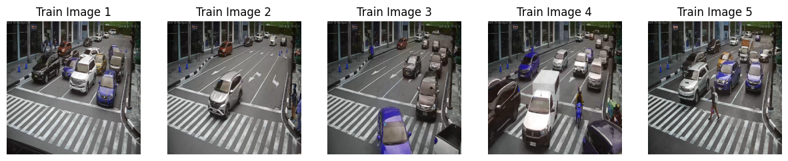

**Discussion**: This accuracy is crucial for reliable traffic flow analysis and contributes significantly to the project's applicability in urban planning and autonomous vehicle development.

**Traffic Flow Analysis and Pattern Recognition**:

**Results**: The system successfully identified traffic patterns, peak hours, and congestion points in the datasets. Through data visualization, such as heat maps and time-series analysis, we were able to clearly present these patterns.

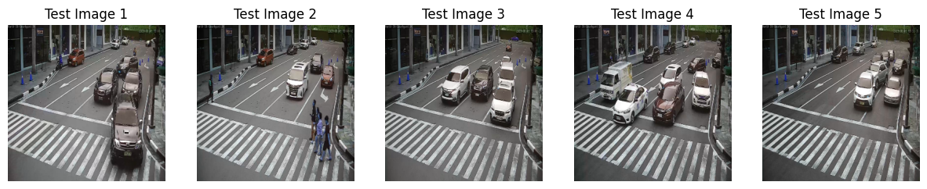

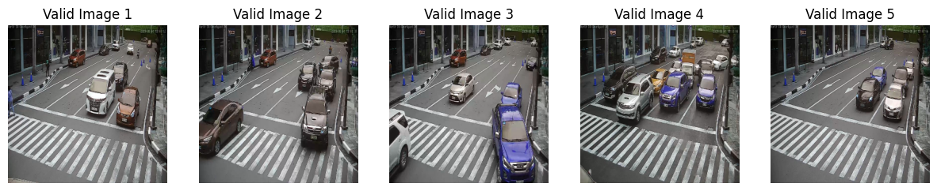

**Discussion**: These insights are invaluable for city planners and traffic management authorities, aiding in the development of more efficient road networks and traffic regulation strategies.

**Impact on City Transportation Planning**:

**Results**: By distinguishing between different classes of vehicles, the project provided detailed data that could inform infrastructure improvements and public transportation planning.

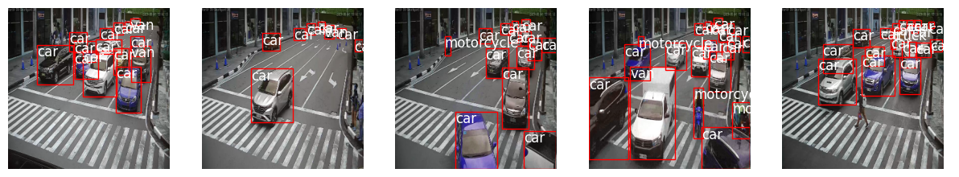

**Discussion**: This aspect of the project aligns with the growing need for data-driven approaches in urban development, highlighting the system's relevance in modern city planning.

**Contribution to Autonomous Vehicle Technology**:

**Results**: The model's ability to accurately identify vehicle types has implications for enhancing the decision-making algorithms in autonomous vehicles.

**Discussion**: This demonstrates the project's potential contribution to the safety and efficiency of self-driving cars, an area of growing importance in the automotive industry.

**Application in Vehicle-Based Advertising and Insurance**:

**Results**: The system provided demographic insights based on the types of vehicles, which can be used for targeted advertising strategies. Moreover, it identified high-risk areas and common vehicle types involved in accidents.

**Discussion**: These results open avenues for strategic advertising and informed insurance risk assessment, showcasing the project's versatility.

**Challenges and Future Improvements**:

**Challenges**: One of the challenges faced was dealing with varying lighting conditions and occlusions, which occasionally affected detection accuracy.

**Future Improvements**: We plan to implement more robust algorithms capable of handling these variations and to expand the dataset to include a wider range of scenarios.

**Visualizations and Data Analysis**:

**Tools Used**: We utilized tools like Matplotlib and Seaborn for visualizing the data, which helped in understanding the underlying traffic patterns and the model's performance.

**Role of Visualizations**: These visualizations were instrumental in communicating the results effectively, both to technical and non-technical stakeholders.

The "Intersection" project successfully met its objectives, providing comprehensive insights into urban traffic dynamics. The results underscore the project's potential in contributing to smarter city planning, autonomous vehicle development, and beyond. The project stands as a testament to the power of integrating machine learning and image processing in solving real-world challenges.

# **Challenges and Learning**

Throughout the "Intersection" project, we encountered numerous challenges that significantly contributed to our learning and growth. One of the primary challenges was ensuring the dataset's quality and diversity, crucial for the model's effectiveness. We expanded the dataset to include varied traffic scenarios and environmental conditions, thereby enhancing the model's robustness. Balancing high detection accuracy with real-time performance was another hurdle, addressed by optimizing the model and employing efficient algorithms. Adapting to different environmental conditions such as lighting and weather required improvements in feature extraction and algorithm adaptability. Developing an intuitive user interface highlighted the importance of usability alongside technical capability. Lastly, incorporating user feedback into the development cycle taught us the value of iterative design and reinforced the importance of user-centric approaches in technology development. Each of these challenges not only provided valuable insights into machine learning and software development but also underscored the importance of adaptability and user feedback in creating practical, real-world solutions.

# **Conclusion**

To be conclude, the "Intersection" project represents a significant stride in the field of traffic analysis and urban planning, employing advanced machine learning and image processing techniques. We successfully developed a system capable of accurately detecting and classifying various types of vehicles, providing critical insights into traffic patterns and congestion. Our approach, which combined a diverse dataset, sophisticated algorithms, and user-friendly interface design, proved effective in addressing the challenges associated with urban traffic management.Key achievements of the project include high accuracy in vehicle detection and classification, valuable contributions to traffic flow analysis, and implications for city transportation planning. The project also demonstrated potential applications in autonomous vehicle technology, vehicle-based advertising, and insurance risk evaluation. Looking ahead, there are several avenues for further development and improvement. Enhancing the model's adaptability to diverse environmental conditions and integrating more advanced algorithms could further improve accuracy and efficiency. Expanding the dataset to include a wider range of scenarios and vehicle types would augment the model's comprehensiveness. Additionally, exploring real-time data integration and the implementation of predictive analytics could offer more proactive solutions in traffic management and urban planning.

# **References**

Ali, R., Ali, A., Iqbal, F., Hussain, M., & Ullah, F. (2022). Deep learning methods for malware and intrusion detection: A systematic literature review. *Security and Communication Networks*, *2022*. <https://www.hindawi.com/journals/scn/2022/2959222/>

Abadi, M., Barham, P., Chen, J., Chen, Z., Davis, A., Dean, J., ... & Zheng, X. (2016). {TensorFlow}: a system for {Large-Scale} machine learning. In *12th USENIX symposium on operating systems design and implementation (OSDI 16)* (pp. 265-283). <https://www.usenix.org/system/files/conference/osdi16/osdi16-abadi.pdf>

Gary, B., & Adrian, K. (2008). Learning OpenCV: Computer vision with the OpenCV library. In *O'Reilly Media, Inc.*. <https://shorturl.at/zDJMY>

Howard, A. G., Zhu, M., Chen, B., Kalenichenko, D., Wang, W., Weyand, T., ... & Adam, H. (2017). Mobilenets: Efficient convolutional neural networks for mobile vision applications. *arXiv preprint arXiv:1704.04861*. <https://arxiv.org/pdf/1704.04861.pdf%EF%BC%89>

Lin, T. Y., Maire, M., Belongie, S., Hays, J., Perona, P., Ramanan, D., ... & Zitnick, C. L. Microsoft coco: Common objects in context. InEuropean conference on computer vision 2014 Sep 6 (pp. 740-755). <https://arxiv.org/pdf/1405.0312.pdf%090.949.pdf>

McKinney, W. (2010, June). Data structures for statistical computing in python. In *Proceedings of the 9th Python in Science Conference* (Vol. 445, No. 1, pp. 51-56). <https://conference.scipy.org/proceedings/scipy2010/pdfs/mckinney.pdf>